**ECPI University Rafat Khandaker**

**CIS-225 09/1/18**

**CIS225: Unit 1 Lab 2: Configuring Ipv6 Protocol**

**Objective:**

Demonstrate the ability to configure an IPv6 protocol.

**Topology:**

Students do not need a specific connection, but should have an active installed interface.

**Instructions and Background:**

IPv6, protocol is an extension and upgrade to the Ipv4 protocol in response to scaling the internet IP address resolution protocol. IPv6 provides a 128-bit address with 48-bit prefix, containing vender and ISP information. A 16-bit address space to allocate subnets & remaining 64-bits for assigning host address. IPv6 also is restricted by a mandatory IPSec protocol. This standard enforces packet-encryption security between 2 hosts on a network. IPSec security is established through an IPSec tunnel to encrypt data between transmission exchanging IKE keys.

**Detailed Instruction:**

In this lab, I will be configuring IPv6 properties on a Linux based system & test the connection using an echo request. This is a Kali-Linux-Rolling distribution of Debian Linux Operating system. Full support for this operating system can be found on <https://www.kali.org/>

**Step 1**

Go into terminal and check the current IPv6 configuration using **ifconfig**

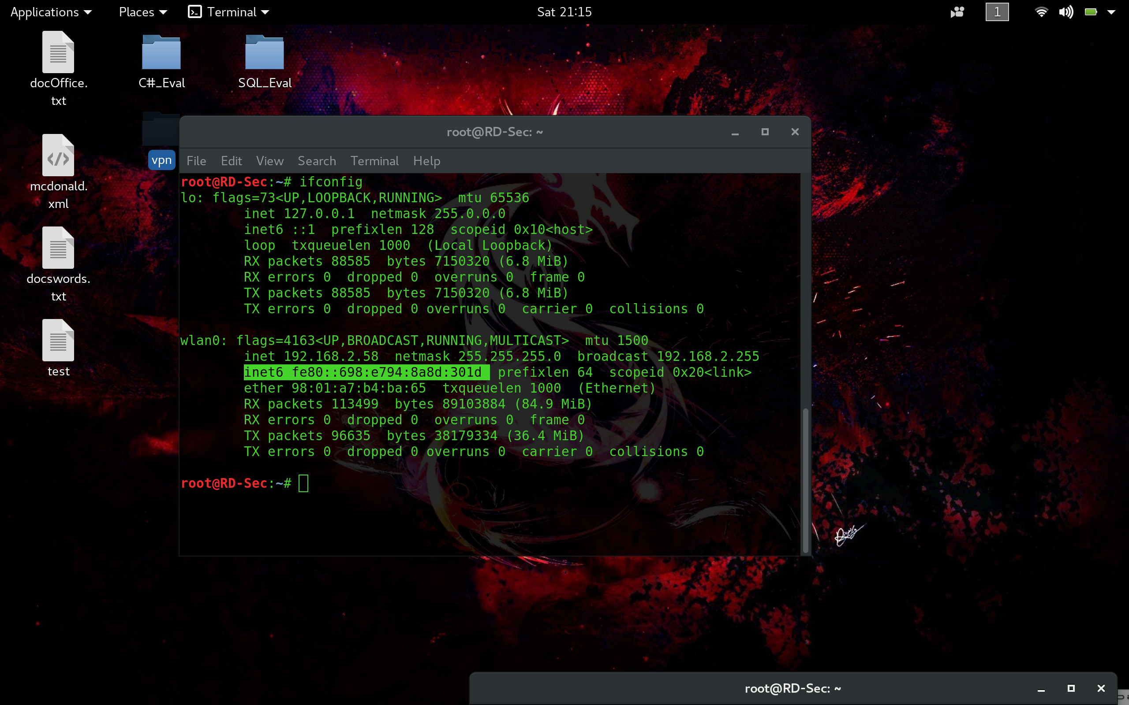

**Alternatively, we can check the network-manager GUI for our configuration on the network connection.**

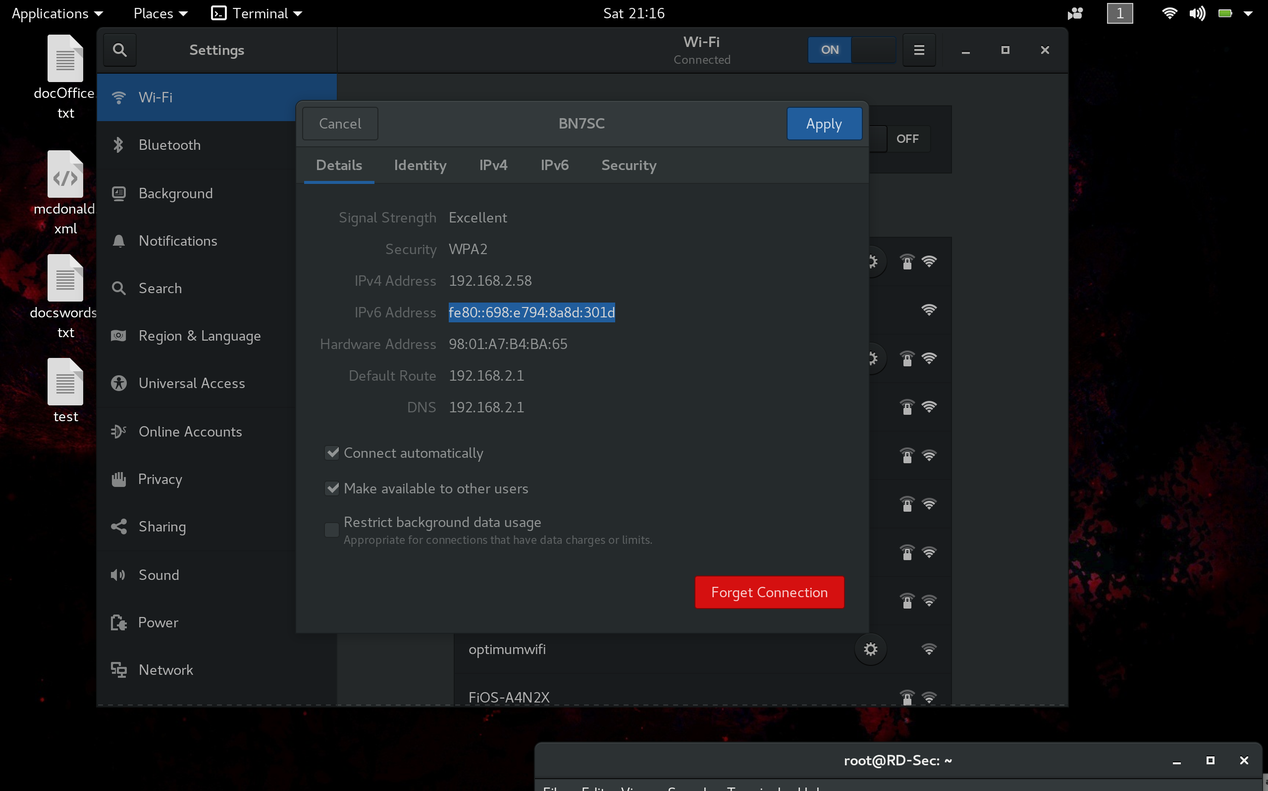

**Step 2**

Next step we will manually configure & apply a static configuration of this address.

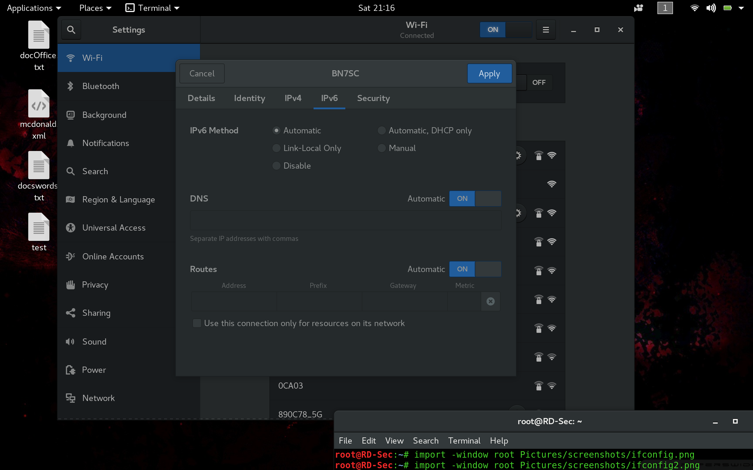

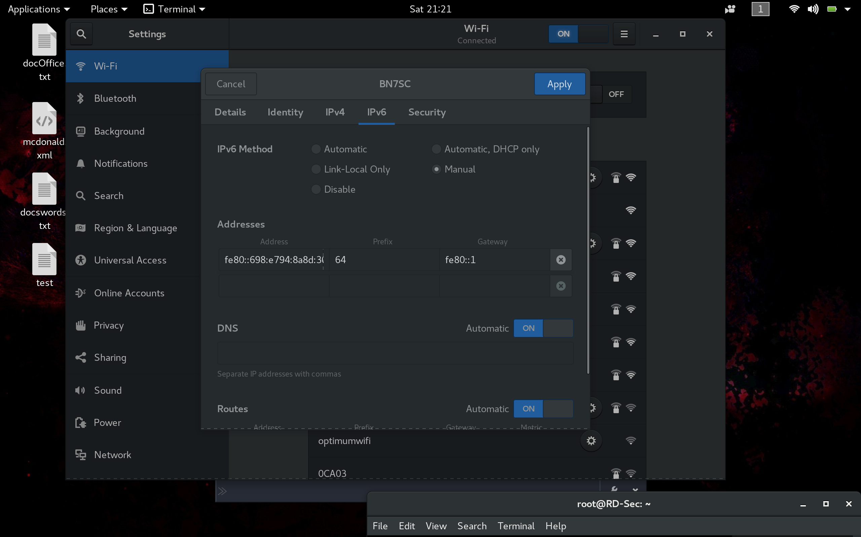

**Step 3**

Last step, we will check our configuration one last time & ping our own device to verify connectivity.

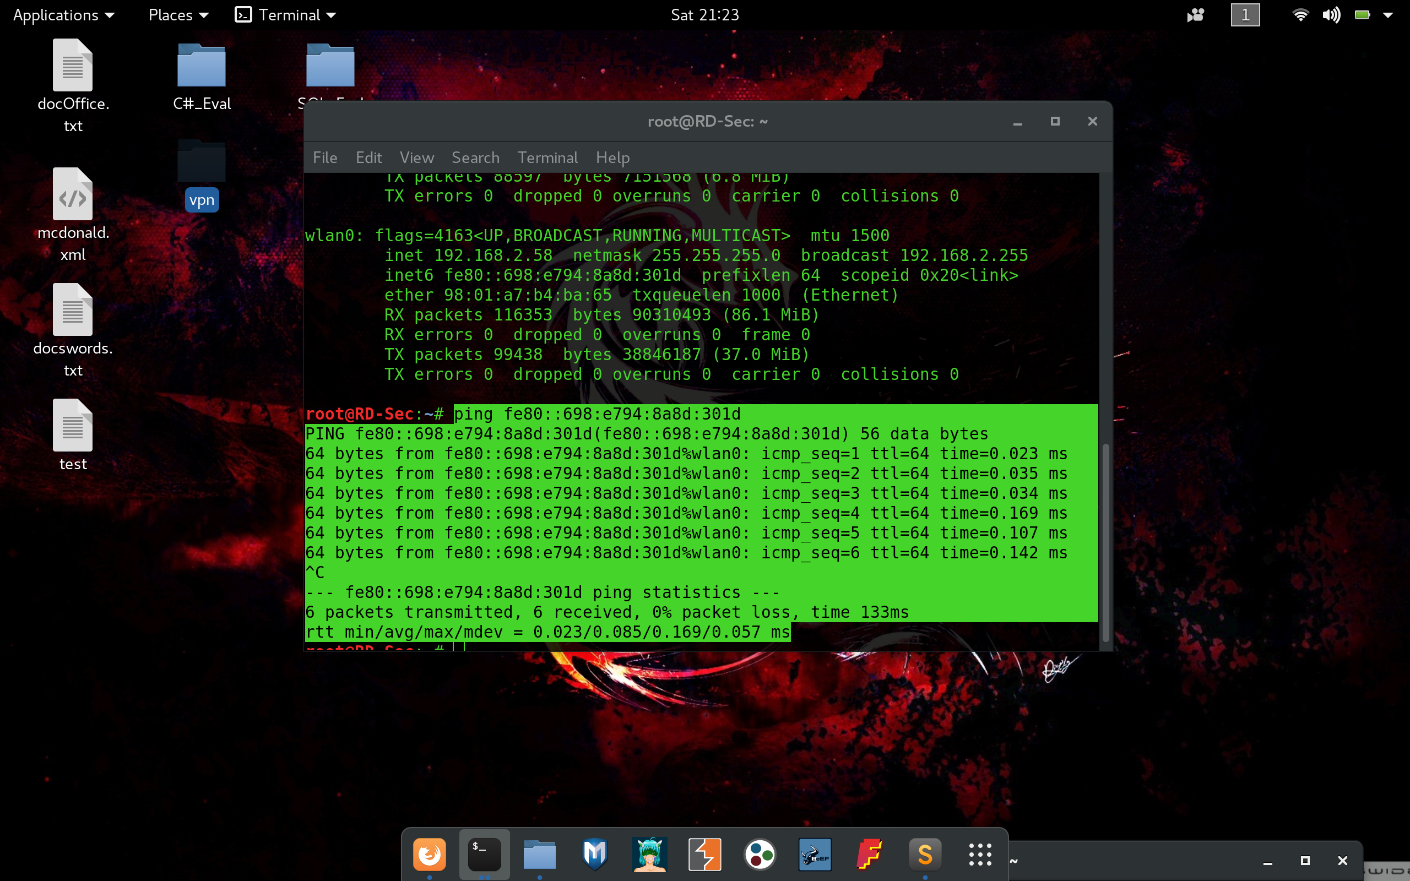

**Summary:**

In summary, the purpose of this lab was to work through the technical procedure of attempting a modify a static IPv6 configuration to a computer system. A lot was learned from the implementation of this IPv6 protocol. I was able to research & understand the benefits of using an IPv6 address as opposed to IPv4. I was able to research the IPSec protocol, which is a mandatory standard implementation of IPv6. I was able to do a basic configuration of an IPv6 address on a local network and verify connectivity. All in all, this lab gave me an insight into current & future models of larger network implementation. Also, gave me insight into the possibilities of a large network-infrastructure.